**George Mason University Physics 244 (F2F)**

# Simple Pendulum

Figure 1: Pendulum - an example for harmonic motion



## Learning Goals:

1. The goal of this lab is to investigate and understand simple harmonic motion.
2. After completing this lab, students will understand what variables affect the period of a pendulum.
3. You will perform am error analysis and determine the uncertainties of your measurements.

## Materials:

Meter stick Photogate Pendulum set, Photogate, pendulum clamp, string, Excel

## References:

Giancoli, Physics 7th Edition: chapter 11

OpenStax, College Physics, chapter 16

## Background Theory:

The motion of a pendulum is a periodic motion. It repeats itself in equal intervals of time due to a variable force acting on it. This force is called restoring force. It is proportional to the horizontal displacement x of the pendulum bob.

$F_{net}=-kx$ (1)

$F_{net}=-\left(\frac{mg}{l}\right)x$ (2)

In equation 2, m is the mass of the pendulum “bob”, g is earth’s gravitational acceleration constant, and l is the length of the pendulum arm.

The pendulum’s equilibrium position is defined as the point at which the net force acting on the pendulum bob is zero. In this case tension and gravitation force balance each other. When a pendulum bob is displaced from its equilibrium position, the restoring force then acts on it, inducing motion back toward the equilibrium position. For a pendulum, the speed of the bob increases as it approaches the equilibrium position, at which it achieves maximum speed. Once the bob passes through the equilibrium position, its speed decreases as it moves up, away from the equilibrium position, until it stops at the peak of its swing. At this point the bob begins to fall back toward the equilibrium position, again subject to the same restoring force, and the changing speed cycle starts over.

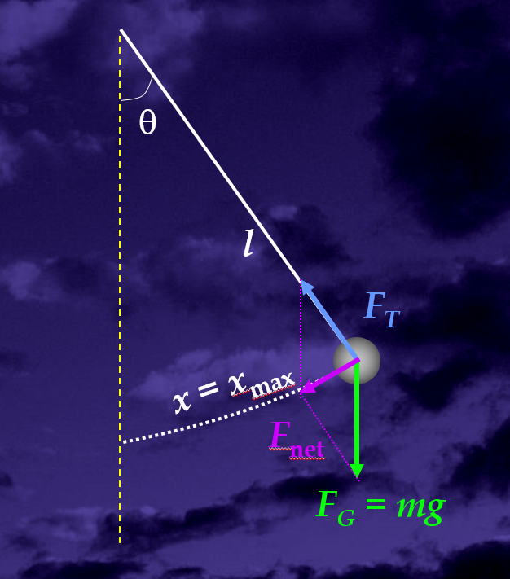

Figure 2: Motion of a pendulum and forces acting on it.

## Experiment:

In this experiment you will use a photogate and the PASCO 850 interface with Capstone to determine how the displacement, the length of the pendulum arm, the material and mass of the bob influence the period of the harmonic motion.

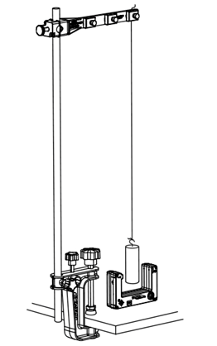

Figure 3: Experimental Set up

### Experimental Set up:

1. Mount the pendulum clamp near the top of the rod and then cut a length of thread as shown figure 3.
2. Choose one of the four pendulum bobs from the PASCO Photogate Pendulum Set (all have identical volume but different mass) and tie one of the loose ends of the thread to the hook on the bob.
3. Hang the pendulum from the third anchor point on the clamp (farthest from the rod): loosen the anchor's thumbscrew and run the thread under the anchor. Tighten the thumbscrew to hold the thread in place.
4. Adjust the pendulum arm length (thread length) so the bob hangs approximately 4 cm above the lab table.
5. With the pendulum bob hanging motionless, place the photogate on the lab table with the arms of the photogate pointed upward, directly under the pendulum bob. The pendulum bob should swing   
   freely between the arms on the photogate.
6. Connect the photogate to the PASCO 850 Interface box.
7. Configure the photogate timer. Go to “Timer setup” and choose pre-configured timer. Choose Pendulum Timer and select the measurements that will be visible (period). Choose a pendulum width of 0.016 m and name the timer.

### Data Collection and Analysis:

**Activity 1:**

1. Use your hand to pull the pendulum bob back, displacing it a horizontal distance of 3 cm from its equilibrium position. Use the meter stick to measure the horizontal displacement.
2. Begin recording data, and then release the pendulum bob so it swings freely through the photogate. Stop recording data when Capstone has recorded 10 period measurements.Create a table in Excel similar to Table 1.

Table 1: Period of a pendulum with varying horizontal displacement

|  |  |  |
| --- | --- | --- |
| Trial | Horizontal Displacement (cm) | Average Period (s) |
| 1 |  |  |
| 2 |  |  |
| 3 |  |  |
| 4 |  |  |

1. Use the tools in Capstone to determine the average of the 10 period data points. Record this average value as well as the horizontal displacement into Table 1.
2. Repeat the same procedure 3 more times, increasing the horizontal displacement by an additional 3 cm each trial. Record your average period and displacement values for each trial into Table 1.
3. Plot a graph of average period versus horizontal displacement. Be sure to label both axes with the correct scale and units.

**Activity 2:**

1. Remove the pendulum bob currently attached to the thread and then measure the individual mass of all four pendulum bobs. Record the mass in order from smallest to largest in a similar table as Table 2 in Excel.
2. Attach the pendulum bob with the smallest mass to the thread.
3. Use your hand to pull the pendulum bob back, displacing it a horizontal distance of 6 cm from its equilibrium position. Use the meter stick to measure the horizontal displacement.
4. Begin recording data, and then release the pendulum bob so it swings freely through the photogate.
5. Stop recording data when the data collection system has recorded 10 period measurements.
6. Use the tools on your data collection system to determine the average of the 10 period data points. Record this value next to its corresponding pendulum bob mass in Table 2.
7. Repeat the same data collection steps 3 more times, keeping the horizontal displacement constant for each trial and changing the pendulum bob, using a bob with increasing mass each time. Record the average period for each trial in Table 2.

Table 2: Period of a pendulum with varying mass

|  |  |  |
| --- | --- | --- |
| Trial | Bob Mass (g) | Average Period (s) |
| 1 |  |  |
| 2 |  |  |
| 3 |  |  |
| 4 |  |  |

1. Plot a graph of average period versus bob mass. Be sure to label both axes with the correct scale and units.
2. Did changing the mass of the pendulum bob affect the period of the simple pendulum? Justify your answer.

**Activity 3:**

1. Use any of the four pendulum bobs, but use the same pendulum bob for each trial.
2. Use the meter stick to measure the length of the pendulum arm. This is the distance from the pendulum clamp to the center of the pendulum. Record this length in Table 3.
3. Use your hand to pull the pendulum bob back, displacing it a horizontal distance of 6 cm from its equilibrium position. Use the meter stick to measure the horizontal displacement.
4. Begin recording data, and then release the pendulum bob so it swings freely through the photogate.
5. Stop recording data when the data collection system has recorded 10 period measurements.
6. Use the tools on your data collection system to determine the average of the 10 period data points. Record this value next to its corresponding pendulum arm length in Table 3.
7. Repeat the same collect data steps 4 more times, keeping the horizontal displacement constant for each trial and shortening the length of the pendulum arm by 10 cm each time. Record your average period and pendulum arm length for each trial into Table 3.

NOTE: To shorten the pendulum arm length, loosen the anchor thumbscrew on the pendulum clamp and gently pull the loose end of the thread upward under the anchor. Tighten the anchor thumbscrew again to hold the thread in place and then lower the pendulum clamp, with the thread and bob attached, so that the bob hangs about 4 cm above the lab table in each trial.

Table 3: Period of a pendulum with varying arm length

|  |  |  |  |
| --- | --- | --- | --- |
| Trial | Pendulum Arm Length (cm) | Average Period (s) | (m1/2) |
| 1 |  |  |  |
| 2 |  |  |  |
| 3 |  |  |  |
| 4 |  |  |  |
| 5 |  |  |  |

1. Plot a graph of average period versus pendulum arm length. Be sure to label both axes with the correct scale and units.
2. Did changing the length of the pendulum arm affect the period of the simple pendulum? Justify your answer.
3. For each part of your experiment, list each variable involved and state whether it was held constant, increased, or decreased.
4. In your experiment, what variables (physical properties) affected the period of a simple pendulum and how did they affect the period? The mathematical equation describing the period Tp of a pendulum is:

 (3)

where l is the length of the pendulum arm and g is earth’s gravitational acceleration constant. Does your data support this mathematical relationship? Justify your answer.

**Sources:** Adapted from PASCO handout